NOAA Remote Sensing summer School

Mark Higgins
EUMETSAT

Introduction
The objectives of this session are:
- Know the construction of [some of the] imagery and products used in operations
- Be able to explain why some RGBS look the way they do
- Answer some of your questions and current and future EUMETSAT data, products, systems, instruments, & missions

Outline of the day:
- [0900-1030] Explain an RGB
- [1045-1200] Phases of convection and the microphysics RGBs
- [1300-1430] Useful Products
- [1445-1600] Future programmes
- [1600-1700] Student presentations

These notes and some other resources are available at https://training.tools.eumetsat.int/course_material/noaa2019/

Learning tasks

Explain an RGB

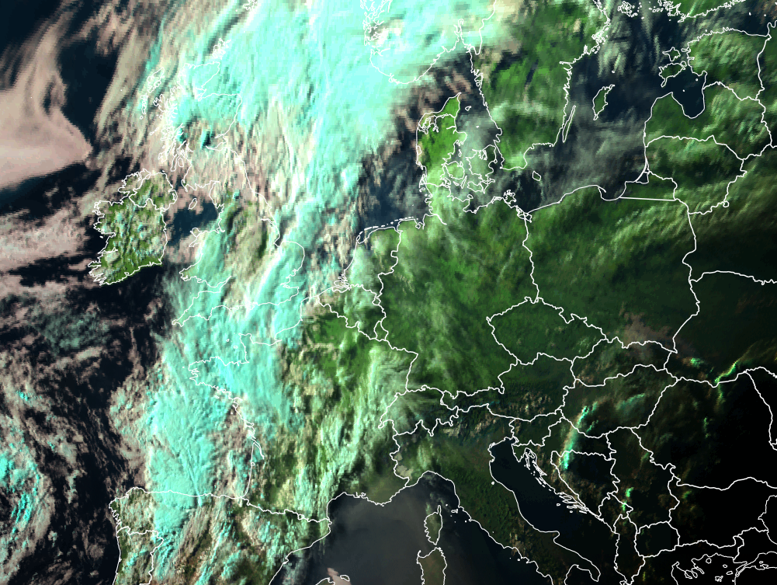 | 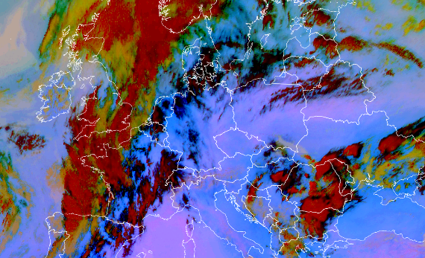 | 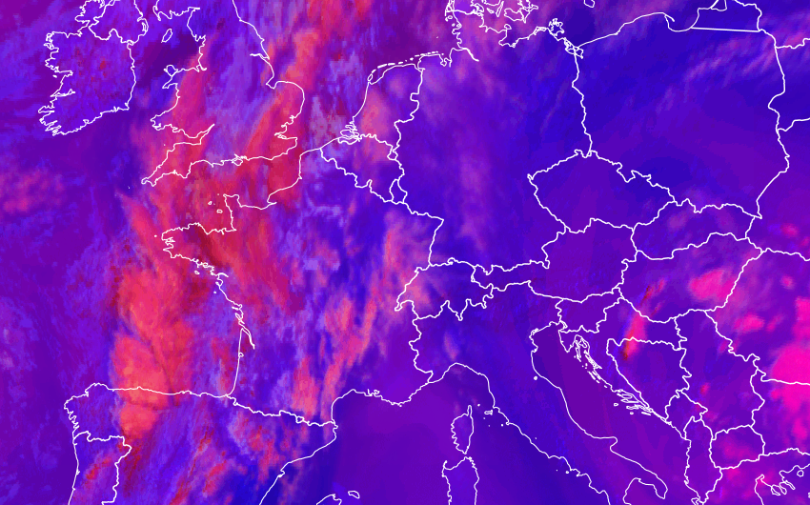
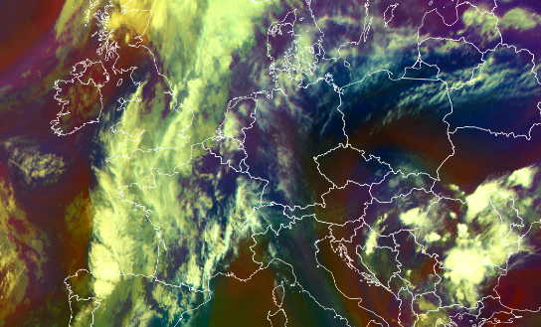 | 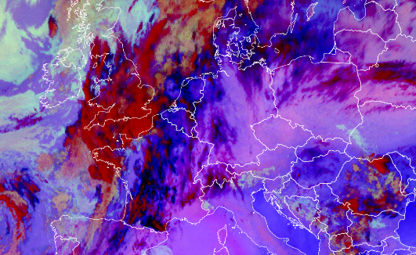 | 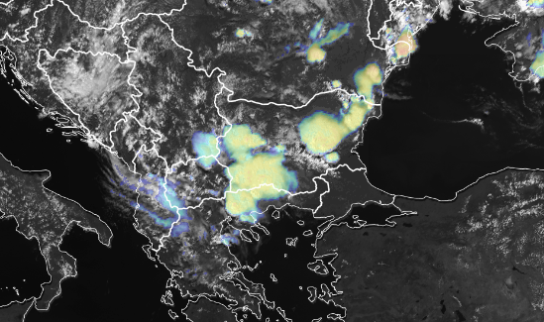

The RGB mages are used in operations around the world. They have names such as: day natural colour, night|day|24hour microphysics, airmass, dust, ash … .

Task: Pick an RGB! Work in groups of 3-4 and generate an explanation of why the RGB looks the way it does. You have 30 minutes; you will then have 2-3 minutes to present back to the wider group.

At the end of this document there are a number of resources you may find helpful (in particular the MSG colour interpretation guide and the quick guides). There are also links to viewers if you want to see the various RGBs

Some questions that may help …
- What are the different channels and channel combinations in the recipe sensitive to?
- What purpose was the RGB constructed for?
- Are there times of day when this RGB is more/less effective; are there other limits to the use?

Phases of convection and the dust RGB

In this section we will use the phases of convection to better understand the dust (and other microphysics) RGB(s).

A really-simple/naïve introduction to the microphysics RGBs

Colour channel | Physical idea | Low value | High value
Red | Thickness | Thick | Thin
Blue | Temperature | Cold | Warm
Green | Particle size | Big | Small

So what colour is:
- A mid-level water cloud
- Cirrus around a storm top
- A mature Cb

Notice that the RGB is designed so that a different physical idea is on each colour. The idea is that the operational meteorologist gets the maximum amount of information in an intuitive manner.

Task: use your favourite viewer and go find some current convection, using the Dust RGB.
- Have a look at a short animation to watch the storm evolve
- Grab a screen shot and annotate some cirrus, Cb and water clouds.
- What questions do you have about what you see?

Low-level moisture (pre-convection)

The dust RGB recipe is:

Colour beam | Channel (difference) | Range | Gamma
Red | IR12.0 – IR10.8 | -4 +2 K | 1
Green | IR10.8 – IR8.7 | 0 +15 K | 2.5
Blue | IR10.8 | 261 289 K | 1

An example of the dust RGB, and some other images is available on the resources page: https://training.tools.eumetsat.int/course_material/noaa2019/ a McIDAS data bundle is also available.

Have a look at the different ingredients:

Q1 How do they correspond to the simple view presented above?
Q2 What difference does land surface temperature and type make?
Q3: The IR12.0 – IR10.8 difference, also called the split window, is on the red colour – what is it sensitive to in addition to the optical thickness?

Later phases

As the storms develop, what other RGBs / image combinations are useful?

Question: what is the operational meteorologist monitoring, and what other sources of information do they have?

Question: what is the operational meteorologist monitoring, and what other sources of information do they have?

Have a looks at the convection working group page: https://www.essl.org/cwg-satellite-guidance/ : The following recommendations are made:

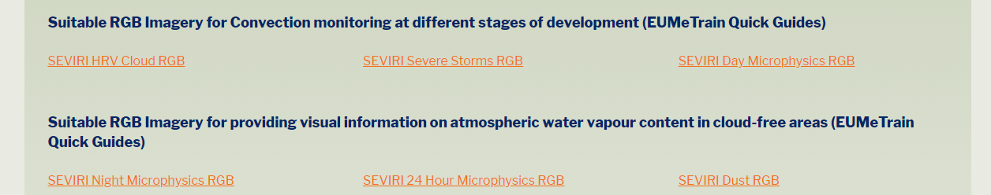

Task: back in groups; look at each of the RGBS recommended for later stages of convection, and look at the sandwich products. Have a look a live data examples using the data viewers. What does the operational meteorologist get from each of the RGBs what do they not get?

products

This session is about products for operations. I’ll show a couple of examples and we will discuss what makes a useful product for operations.

IR/Microwave sounding products

As you know … we can get vertical structure information from sounders

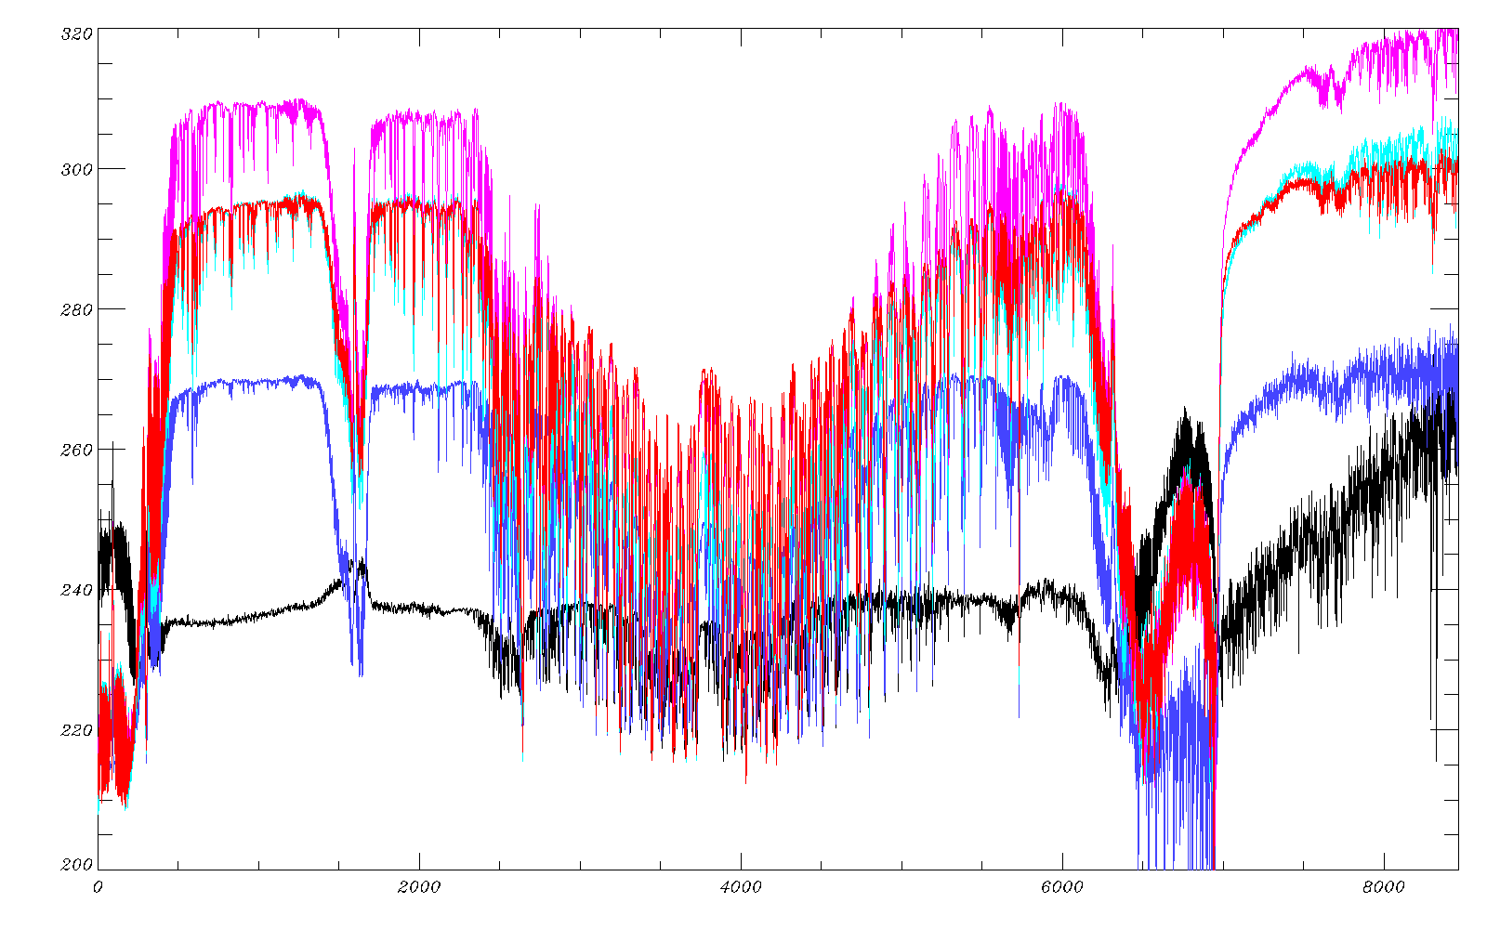

(Above) Some example IASI profiles (Top to bottom: Australia, Pacific, Atlantic, Arctic, Antarctic in December 2013, by IASI channel number)

Spectrum geek test: what information is where?

Of course we can’t see through the clouds in IR, but we can with microwave …

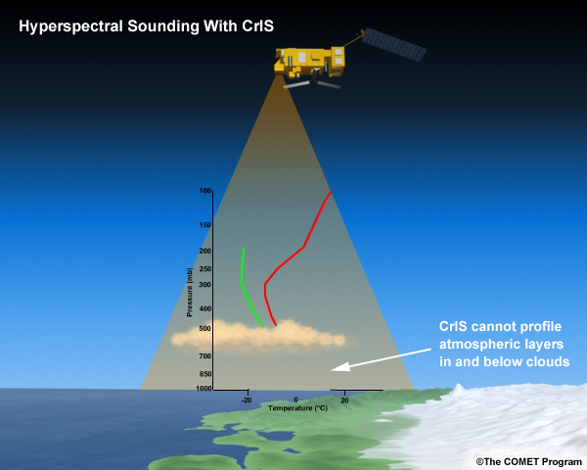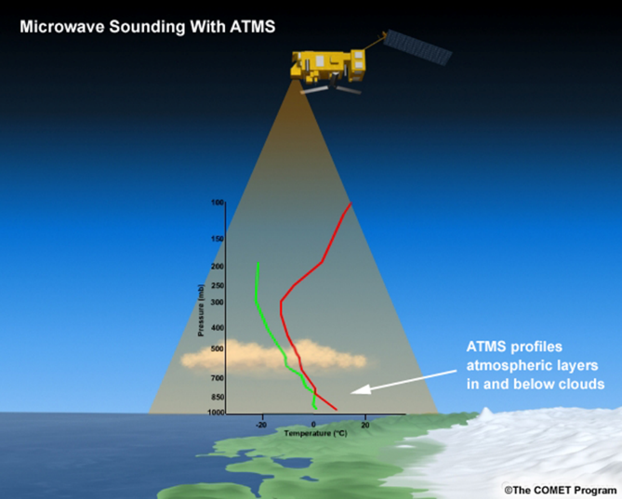

So we produce a combined “IASI-level 2” product
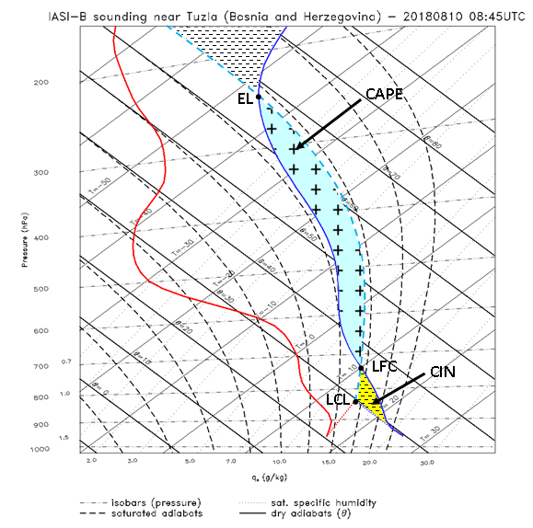

This example is from a IASI-Level2 temperature and humidity product.

Question – is this diagram useful?

(If these diagrams are new to you there is a really nice comet lesson on skew-t or tephigram)

Here are the averaging kernels for the product:

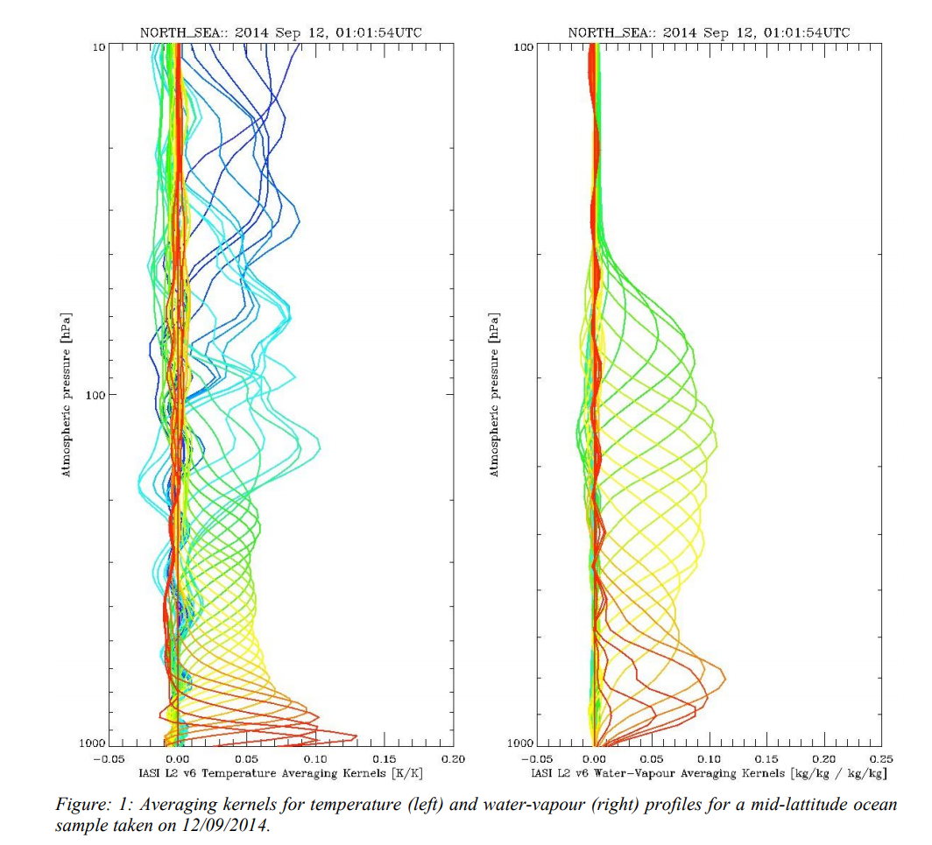

Retrieved products from satellite data are great … but
We record some kind of count at the sensor, which is conveted to a radiance or some other sensor-based parameter) from which we derive geophysical quantities; it is those geophysical quantities that are used further downstream in modelling or by a person.

In this case, the big challenge is the smooth nature of the retrieved profiles and the near surface uncertainties. They are a fact of the retrieval – the question is how to use the retrieved data well.

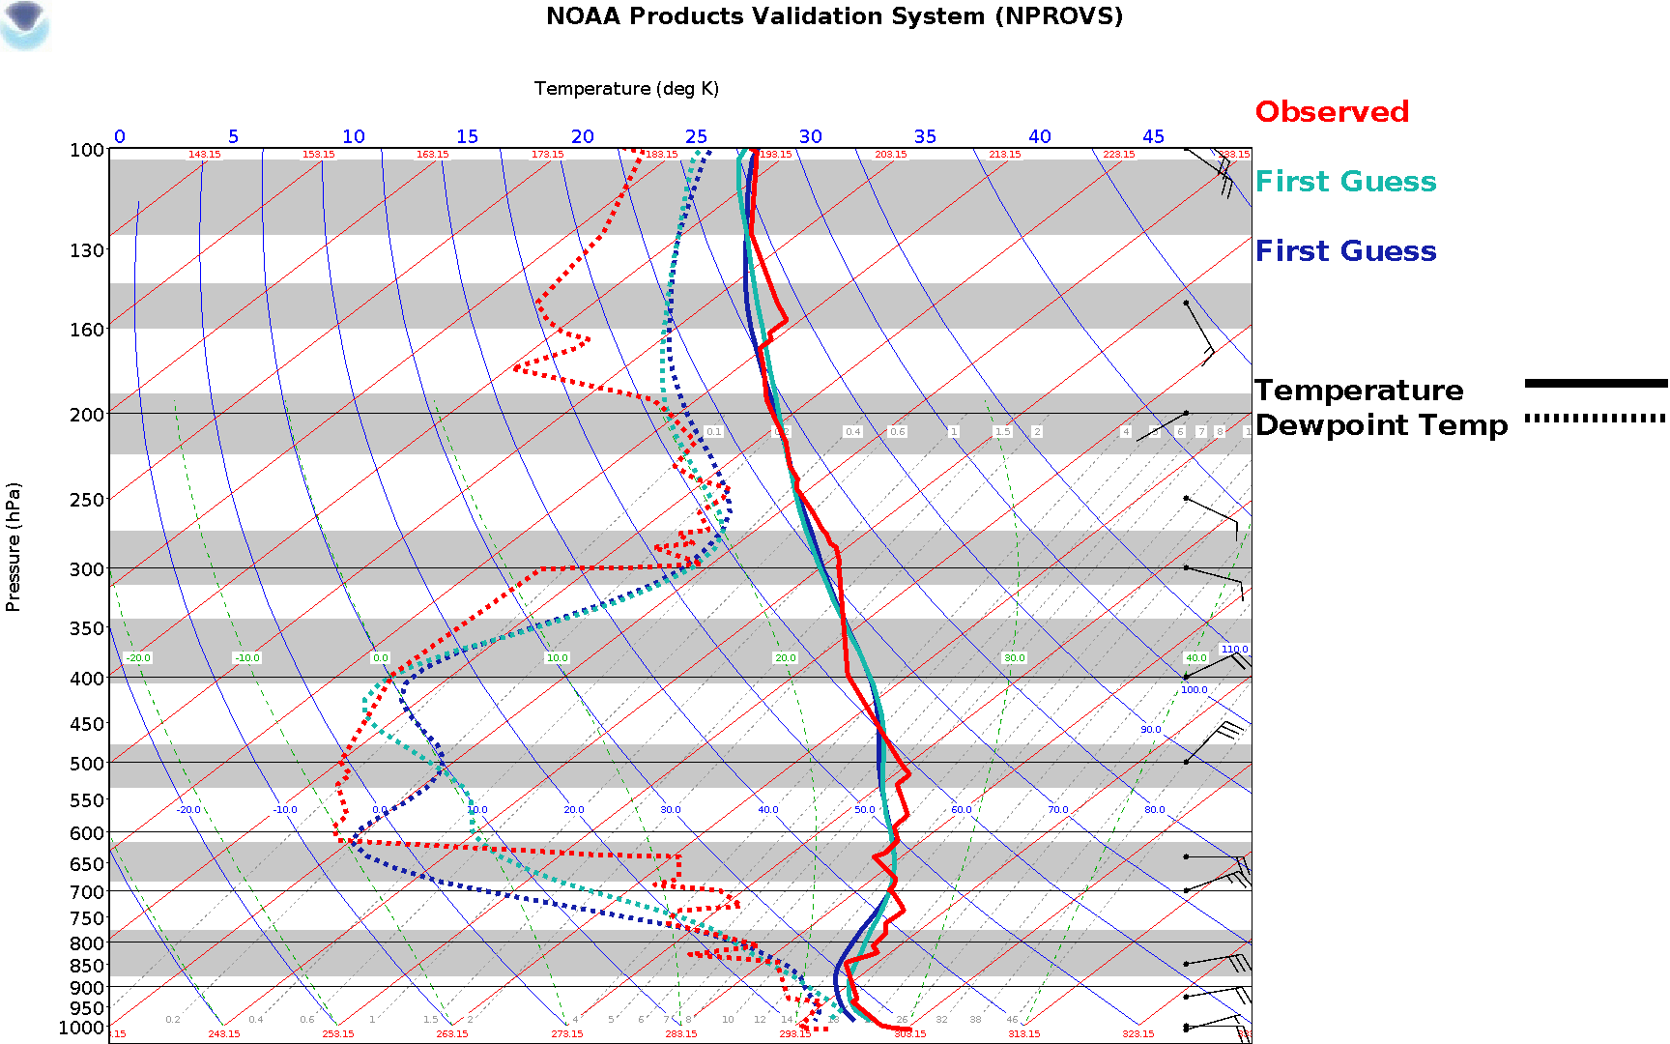

Below is an extract from the product handbook:

3.3.2 Vertical resolution of the temperature and humidity profiles
Users should consider carefully the definition of the IASI temperature and humidity profile products required for their particular application. The IASI sounding products represent thermodynamic states of deep atmospheric layers at variable depths, due to the integrating nature of the radiation measurements at the top of the atmosphere. The maximum number of independent pieces of information determined in the temperature profile is 14, with a maximum of 10 pieces for the moisture profile—but these numbers vary with the atmospheric situation. In summary, the true vertical resolution of the retrieved profiles is lower than the vertical grid defined in the products. Profiles retrieved from such radiance measurements are smoothed versions, where the smoothing functions are the averaging kernels. An example of a set of averaging kernels for temperature and humidity is shown in Figure: 1 . Two things can be seen: the vertical extent over which a particular kernel averages, and the amplitude, which shows how sharply a kernel peaks at a particular height. Higher amplitudes indicate more information about the corresponding layer. For example, an amplitude of one would indicate perfect measurements at a distinct level; however, this is purely hypothetical and does not exist. Nevertheless, the retrieved profiles are represented on a fine vertical grid for the reason that the averaging kernels vary with atmospheric situation. Consequently, the vertical resolution and the centre altitudes of the resolved layers vary also. The actual variation is not known a priori, so the retrieval is performed on a fixed, fine pressure grid and the smoothing is represented by the a posteriori error covariance matrix, which is part of the product and represented on the same pressure grid. The off-diagonal elements of the covariance matrix describe the inter-relationship between the state-vector elements and provide information about the actual vertical resolution.

A challenge for those of us working closer to down-stream users is how to help people use the best of the retrieved data within its limitations.

Question – what other ways could operational meteorologists use data like this?

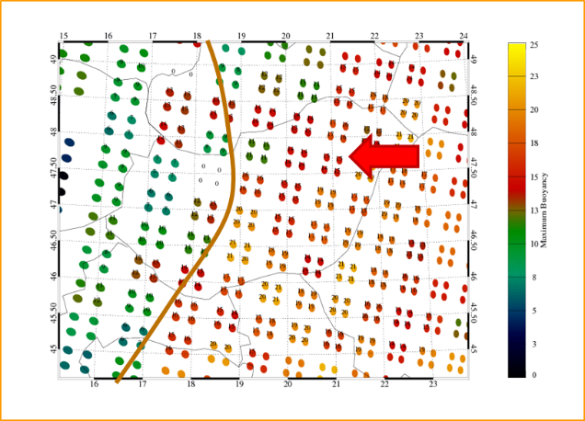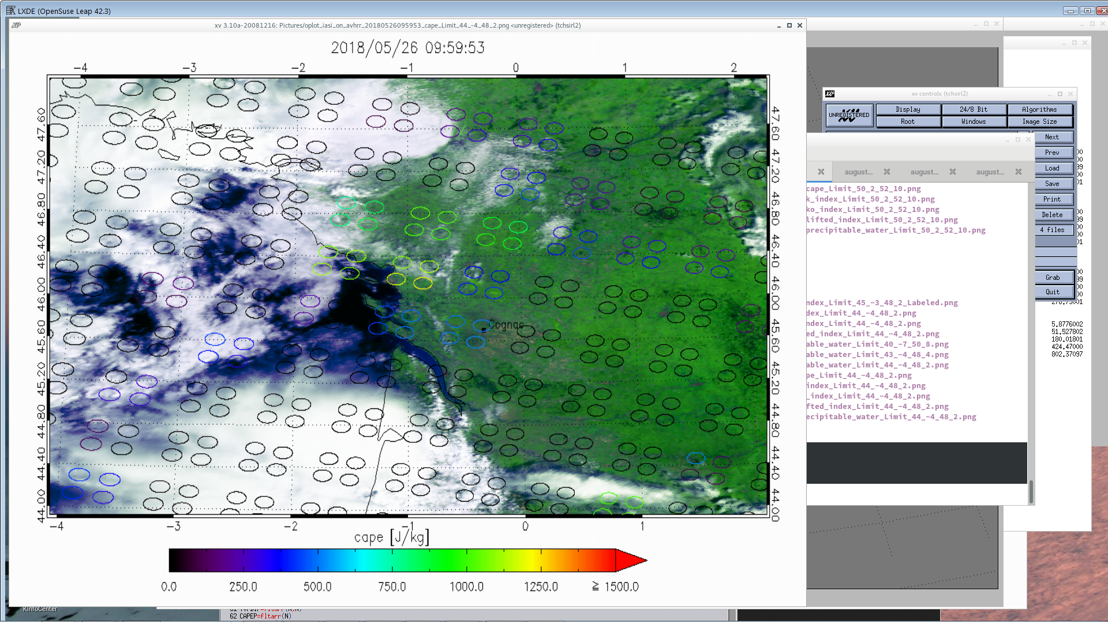

ASCAT retrievals

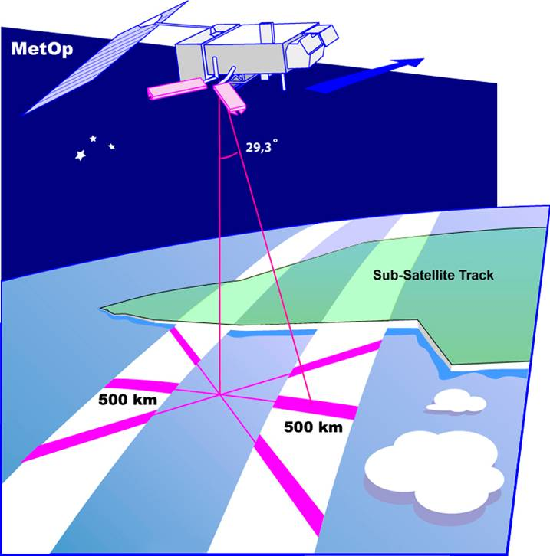
ASCAT is a C-band scatterometer on board metop. It’s a radar with 3 antennas in fixed positions.

For any point on the swath we get 3 backscatters, from which a 10m neutral wind can be retrieved over water.

There is ambiguity in the wind direction, so an NWP surface wind field is used to constrain the retrieval.

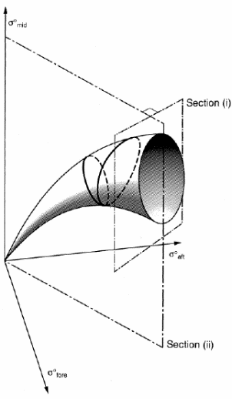
For ASCAT the function used to map from backscatter to ideal wind is a 3D function and looks like a cone. In the minimisation process there will be a distance from the cone of the minimised solution and the nearest point on the cone. This may be inside or outside of the cone.

The ambiguity leads to multiple possible wind solutions, ranked by probability and the retrieval gives an estimate of the distance of the most probable wind solution from the cone. This is also known as maximum likelihood error (MLE).

Question: should we show this information to the operational meteorologist?

The ascat retrievals are available at
- https://manati.star.nesdis.noaa.gov/datasets/ASCATData.php/ and
- http://projects.knmi.nl/scatterometer/tile_prod/tile_app.cgi

It turns out that high MLE values usually indicate high spatial wind variability or rain presence in the Wind Vector Cell.

Task:

Have a look at the ASCAT sciences from the KNMI viewer – what cases lead to high MLE?

Ambiguities can also be plotted, have a look at the NOAA viewer, when are the ambiguities most clear? When might ambiguity be most significant?

Both these products show the importance of engaging with the users in their frame of reference and understanding what they need to achieve. There are many more great ideas out there (maybe even yours) than are used in operations.

NexT Generation

See the presentation files

Data visualisation tools
During the course, we will have the opportunity to use McIDAS-V (version 1.8). If you download the software before the course add the “EUMETSAT RGB” plugin (under tools > plugins > manage plugins).

pyTroll is an open source python library used extensively for data visualisation in Europe.

McIDAS-V: https://www.ssec.wisc.edu/mcidas/software/v/
pyTroll: https://pytroll.github.io/

Bonus material

What information is where is IASI:
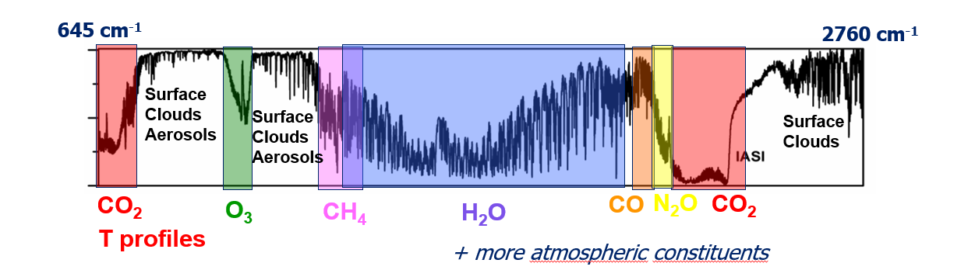

useful Resources

COMET lessons:
- Basic satellite imagery interpretation
https://www.meted.ucar.edu/asmet/asmet10/index.htm
- Basic satellite & NWP integration
https://www.meted.ucar.edu/lesson/1408
- Basics of visible and infrared remote sensing
https://www.meted.ucar.edu/asmet/asmet1/
- RGB products explained
https://www.meted.ucar.edu/satmet/multispectral_topics/rgb/
- Creating meteorological products from satellite data
https://www.meted.ucar.edu/EUMETSAT/products/print.htm

Viewers
- CIRA slider: http://rammb-slider.cira.colostate.edu
- EUMETView: https://eumetview.eumetsat.int/mapviewer/
- ePort from eumetrain: http://eumetrain.org/ePort_MapViewer/index.html
- mark’s view: https://training.tools.eumetsat.int/view/

Convection working group documents:
- CWG home https://www.essl.org/cwg/
- Best practice document:
https://www.essl.org/cwg/res/pdf/BP-EUMETSAT_20140612.pdf
- Reference documents by convective phase
https://www.essl.org/cwg/?page_id=33

EUMETSAT documents
- MSG interpretation guide: http://www.eumetrain.org/IntGuide/ and
- MSG colour interpretation guide http://www.eumetrain.org/RGBguide/rgbs.html
- Eumetrain (eumetsat training project) main site: http://eumetrain.org/
- Library of conceptual models: http://eumetrain.org/satmanu/index.html
- RGB quick guides http://eumetrain.org/rgb_quick_guides/index.html
- RGB application in operations:
http://www.eumetrain.org/resources/operational_use_rgb.html

